F1 Pitwall · Lambiase Edition – User guide
Oct 25, 2026 · @Nina Geurds

Introduction and legend
The Pitwall replays historical F1 races (2023+) lap by lap and shows, at every moment, what a race engineer on the pit wall would see: positions, gaps, tyres, telemetry and a strategy call. Everything on screen is either measured (timing and telemetry), calculated from it, or a model result with assumptions. This guide states which of the four applies to each visual.
Label | Meaning | How reliable
DATA | Straight from the official timing / telemetry (via OpenF1 and Jolpica), only cleaned or converted | As good as the source; ~4 samples per second
DERIVED | Calculated from DATA with no choices that steer the result (e.g. acceleration = Δv/Δt) | High, but sensitive to measurement noise
MODEL | Calculated with a simplified model of reality (e.g. linear tyre degradation) | Indicative; see the assumptions overview
ASSUMPTION | A fixed value or rule we choose because the data does not contain it (e.g. 100 kg starting fuel) | Depends on how good the estimate is
Important: the replay only uses what was known at that moment. Charts and strategy therefore never show future laps, except the expected fuel load and the race distance. One exception is noted under Tyre wear & degradation.

Data sources and processing
All raw data comes from two free public sources; calculations run in the Python ETL and, for the strategy, live in the visual.
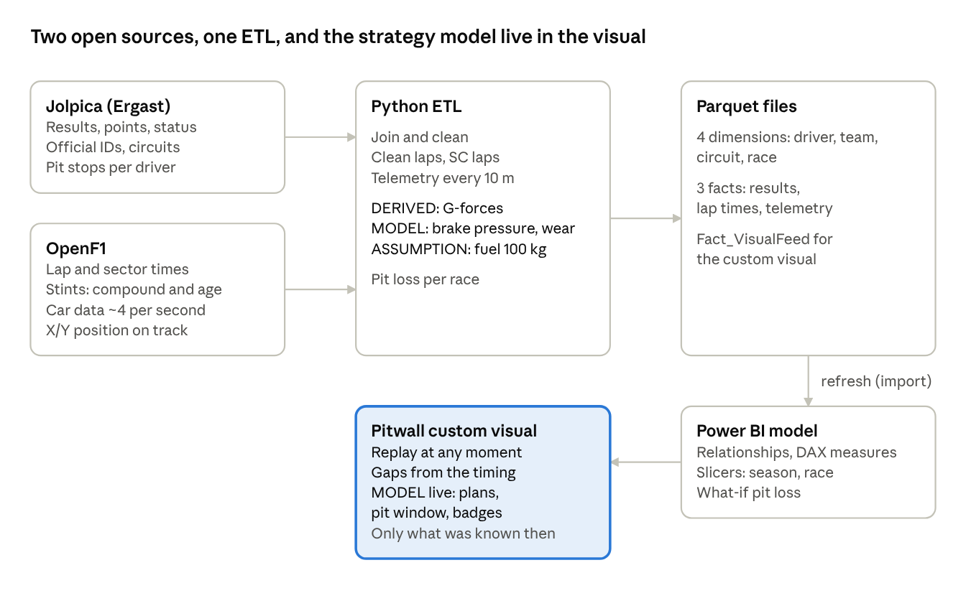
data flow · sources → ETL → Parquet → Power BI → visual
- Jolpica (successor to Ergast) supplies official results, IDs and pit stops.
- OpenF1 supplies lap times, sectors, tyre stints and the raw car data (~4 samples per second: speed, throttle, brake on/off, gear, DRS, X/Y position).
- FastF1 works as an alternative, but since version 3.9 it requires an F1TV subscription.
- Sample data: 8 races (2023 and 2024, incl. Bahrain, Monaco, Zandvoort, Spa). Telemetry is included only for each driver's fastest lap, with one point every 20 m.

Controls
Pick a race and two drivers at the top, then play the race with the Lap timeline at the bottom. Every panel follows the same clock.
Control | What it does
Tabs (Strategy, Telemetry, Pit stop, History, Tyres, Rival analysis) | Only switch the layout; the selected race, drivers and lap stay the same
Season / Grand Prix | Picks the race from the loaded data. Title, track, lap count and all panels follow
Driver (red) | The focus driver: all strategy, the pit window and the Lambiase calls are about this driver. Can also be picked by clicking a car on the map or a row in the standings
vs (yellow) | The comparison driver in telemetry, tyre wear and lap times. Also via right-click on a row
Lap timeline | Click or drag to jump to a moment. Red dot = focus pit stop, yellow = rival pit stop, blue band = predicted pit window, white line = focus lap times so far
Play / Pause / Reset | Starts the replay, pauses it, or jumps back to lights out
Speed 1x – 60x | 1x is real time (a race then takes ~1.5 hours); 20x and 60x to move through a race quickly
[ Emergency Restroom View ] | Portrait phone layout with the same panels stacked. Also switches on automatically when the visual is narrower than 720 pixels
Tip: add a Season slicer to the Power BI page. The visual then loads less data (≈5–7k rows per Grand Prix) and starts faster.

Live track map
The track is measured; the car positions are a reconstruction. The feed only holds telemetry for each driver's fastest lap, not for every lap.
Element | Source | Explanation
Track outline | DERIVED | X/Y positions of the fastest lap of the race (the reference lap), every 20 m
Position of each car | MODEL | From the real start and end time of its current lap (DATA) and the pace profile of the reference lap: a car that has driven 40% of its lap time sits where the reference car was after 40% of its time
"PIT" label | ASSUMPTION | Last 14% of the in-lap and first 12% of the out-lap. The pit lane itself is not drawn
DRS zones (green) | DATA | Where the DRS flap was open on the reference lap
Sector markers | DERIVED | Official sector times of the reference lap converted to distance
Info card: Speed, Throttle, Gear | MODEL | Value from the focus driver's fastest lap at his current spot on track, so not a live reading of this lap
Info card: S1, S2, S3 | DATA | Latest official sector times; purple = fastest of anyone so far, green = personal best, yellow = slower
Focus driver label | DATA | Position and interval from the timing (see Race order)
Speed mode | DATA | Speed of the focus driver on his fastest lap as colour (blue = slow, red = fast)
Track length (bottom) | DERIVED | Integrated from speed; ~1–2% shorter than the official length because of the sample rate
So use the map for the picture of the race (who is near whom), not for exact distances between cars. The gaps in Race order are more reliable for that.

Race order & tyre life and Timing tower
Standings, gaps and tyres come from the timing; tyre life and degradation are model values. Race order is on Strategy, Pit stop and Tyres; the Timing tower (with sectors and lap time) is on History.
Column | Source | Explanation
Pos | DERIVED | Order in which cars crossed the last timing line (finish, end of sector 1, end of sector 2), as on the official timing screen
Gap | DERIVED | Time difference at the same timing line. Race order: to the car ahead. Timing tower: to the leader, with Int next to it. "+1 LAP" = lapped. Updates per sector
Tyre: letter + age | DATA | Compound and number of laps on this set, including laps from qualifying (OpenF1 stints)
Tyre: "/24" | MODEL | Expected life of that compound in this race: √(2 × pit loss ÷ degradation per lap), using the whole field's degradation so far. Without data: ASSUMPTION 18 (soft), 28 (medium), 38 (hard)
Life bar | MODEL | Remaining share of that life: green > 45%, yellow 20–45%, red < 20%
Degradation | MODEL | Cumulative time lost to tyre wear in the current stint, after fuel correction (see Tyre wear)
PIT / OUT | DATA | In the pit lane (see the assumption under the map) / retired according to the official result
Last lap (purple) | DATA | Latest lap time; purple = fastest lap of the race so far
Sectors | DATA | Colours per sector as on the info card; bright = this lap, dimmed = previous lap
Note: the Degradation column uses a reference time per stint that the ETL calculates over the whole stint. In the middle of a stint this number therefore looks slightly ahead. The strategy itself does not.

Pit window strategy, plans and badges
This panel is the strategy model: for the focus driver it calculates whether 0, 1 or 2 more stops is fastest to the flag, and when. It is a MODEL based on measured degradation, not a prediction of what the team will do.
How it calculates
- Degradation per lap (d) – MODEL. The slope of fuel-corrected lap time against tyre age over the clean laps of the current stint (at least 5). Too few laps? Then the field average on the same compound so far. The label STINT or FIELD says which one.
- Pit loss – DERIVED. Per race the median of (in-lap + out-lap − 2 × normal lap) for green-flag stops. If that fails: ASSUMPTION 22 s. On the Pit stop tab you can change it with ± (what-if).
- Plans A/B/C – MODEL. Every stop lap for 0, 1 and 2 more stops is calculated: running a set of age a costs d × (a+1 + a+2 + …) seconds; a new set starts at 0 with the same degradation; each stop costs the pit loss. The cheapest plan is A; the others show the difference in seconds.
- Pit window – MODEL. Every lap for plan A's first stop that is at most 1.0 s slower than the best moment.
- Rules – In a dry race every car must use two different dry compounds; until that has happened, "no stop" is excluded. With intermediates or wets the model pauses.
The chart shows the classic rule of thumb: the white line is the accumulated loss d × age² ÷ 2, the dashed yellow line the pit loss. Where they cross (yellow dot) a stop has been "earned". The blue band is the pit window from the plans above. Current fuel is an ASSUMPTION-based calculation (see Tyre wear).
Badge | When | Source
Undercut threat HIGH / MODERATE / MINIMAL | If the car behind pits now, it gains about 2 × d × your tyre age − 1 s (warm-up). More than the interval = HIGH, within 1 s = MODERATE. No threat when your tyres are fresh or the car behind is already on newer tyres | MODEL
Clean exit gap / Traffic on exit · P# | Your gap to the leader + pit loss, compared with everyone else's gap. A car within 1.5 s = traffic. P# = position after the stop | MODEL
Pit window open / Box box · this lap | The current lap is in the window / the best moment is now | MODEL
Tyres make the flag | Plan A has no more stops | MODEL
2nd compound still required | Only one dry compound used so far | Regulations + DATA
Wet / mixed conditions | Intermediates or wets in use (last 10 min) | DATA
Not in the model: Safety Car or VSC probability, pace difference between soft, medium and hard, traffic and overtaking difficulty, available tyre sets, and reactions to rivals.

Tyre wear & degradation and Degradation vs fuel load
Tyre wear is not measured; we derive it from lap times after removing the fuel effect. Two effects overlap: the car gets faster as the tank empties, and slower as the tyre wears.
Fuel correction (ASSUMPTION)
- Start with 100 kg of fuel (the maximum is 110 kg), burned linearly to 0 at the flag.
- Each kilo costs 0.033 s per lap.
- Fuel-corrected lap time = lap time − fuel in kg × 0.033. That is the time "on an empty tank".
Clean lap (ASSUMPTION) – not an in-lap or out-lap, not lap 1, not a Safety Car lap (field median more than 10% above the race average) and at most 7% slower than the driver's own median. Only clean laps count for degradation.
Tyre wear & degradation (Strategy, Tyres) – MODEL. For each clean lap the time lost in seconds versus the start of that stint (the trend line at the first clean lap), for the focus driver (red) and the rival (yellow). Dots take the compound colour; the blue band is the pit window. This is the exception mentioned in the introduction: the reference time per stint is calculated in the ETL over the whole stint.
Degradation vs fuel load (Pit stop) – per lap so far:
Element | Source
Coloured dots: clean laps, fuel-corrected | DERIVED (with fuel ASSUMPTION)
Grey dots: all other laps, fuel-corrected | DERIVED
Dashed blue line: fuel in kg (right axis) | ASSUMPTION
Coloured line: degradation trend of current stint | MODEL (straight line through the clean laps)
Dashed orange line: projection past the window | MODEL (trend extended)
White "PIT" lines | DATA
Drop-off tile | DERIVED: average of the last 3 clean laps minus the first 3 of the stint
Tyre · Opt. age tile | DATA (tyre) + MODEL (rule-of-thumb age)

Telemetry: raw telemetry and derived physics engine
Telemetry compares the fastest lap of the focus driver (red) with the rival's (yellow), plotted against distance from the finish line. It is therefore not the lap the replay is on. Move the mouse over the chart: values appear on the left and a circle marks the spot on the track map.
Channel | Source | Explanation
Speed (km/h) | DATA | Speed sensor, ~4 samples per second, converted to one point every 10–20 m
Throttle (%) | DATA | Throttle pedal 0–100%
Brake on/off | DATA | The public feed only says whether the brake is pressed, not how hard
Gear | DATA | Gear 1–8
Δ Time | DERIVED | Elapsed lap time of red minus yellow at the same distance (both laps scaled to the same length). Above zero (yellow area) = red loses time, below zero = red gains
G Long | DERIVED | Longitudinal acceleration a = Δv/Δt, calculated as speed × change of speed per metre, after smoothing over 90 m
G Lat | DERIVED | Lateral acceleration = speed² × corner curvature from the X/Y line. Positive = left-hander. Noisier than G Long; capped at ±6.5 g
Brake press. (%) | MODEL | Braking deceleration minus the part already explained by drag and engine braking (measured per race while coasting), scaled so the hardest 2% of braking in that race is 100%. Not a sensor value: only comparable within one race
G-G diagram | DERIVED | Each point is G Lat against G Long on the lap. A fuller circle means the car more often brakes or accelerates while turning
Known limit: at ~4 samples per second, peaks are smoothed. Braking comes out at ~4–4.5 g, while real F1 cars reach 5–6 g.

Driver telemetry comparison
Five indicators from the fastest lap of red and yellow side by side. They say something about driving style and set-up, not about the standings at this moment.
Bar | Source | Calculation
Top speed (km/h) | DATA | Highest measured speed. Bars start at 70% of the maximum so small differences stay visible
Brake pressure (% avg) | MODEL | Average estimated brake pressure while braking (see Telemetry)
G-Force (peak g) | DERIVED | Highest combined acceleration √(G Lat² + G Long²)
Full throttle (% of lap) | DERIVED | Share of the lap at 98% throttle or more
Gear usage (avg) | DERIVED | Average gear over the lap
The phone layout drops Full throttle to save space.

History and Tyres: lap chart, lap times and tyre strategy
These three charts are almost pure data and only show laps already completed.
Visual | Tab | Source | Explanation
Lap chart | History | DERIVED | Position of every car at the end of every lap: the order in which they crossed the line on that lap. Red and yellow are thick, the rest thin in team colour. For lapped cars the position is an approximation
Lap times | History, Rival analysis | DATA | Official lap times of red and yellow; in-laps and out-laps left out to keep the scale readable
Tyre strategy | Tyres | DATA | Per car (in current running order) the stints so far: colour = compound, letter + number = compound and number of laps. Clicking a row makes that driver the focus

Strategy for Lambiase and Team radio
Strategy for Lambiase sums up the strategy model in three short calls for the focus driver. They are rules on top of the MODEL, not extra analysis.
Call | Rule
Red: "Target L38 for H" or "Stay out · tyres to the flag" | First stop of plan A. The compound is an ASSUMPTION: more than 26 laps left = hard, more than 14 = medium, otherwise soft. No more stops in plan A = stay out
Blue: "Plan A: 1 stop · 12.1 s faster than no stop" | The best plan and the difference to the second plan
Grey: Defend / Attack / Watch | Defend when the car behind is within 1.2 s; Attack when the car ahead is within 1.5 s; otherwise Watch the car behind
The round badge shows the driver code, position and team colour. Driver photos are deliberately not used.
Team radio (RADIO MAX) is atmosphere and has nothing to do with the race data. The button plays the embedded audio clip (from your folder), preceded by two classic radio beeps and passed through a 300–3400 Hz radio filter. Without a clip you only hear beeps. The equalizer and lights really follow the sound. "Last call" shows on which lap you pressed the button.
Note: the clip is audio material owned by F1 and the broadcaster. Fine for personal use, but do not share the .pbiviz publicly.

Assumptions and reliability
On average the strategy model is ~4.6 laps away from the real stop lap; all fixed assumptions are listed here in one place.
Assumption | Value | Used in | Effect if wrong
Starting fuel | 100 kg, burned linearly | Fuel correction, Current fuel | Degradation slightly too high or too low
Fuel effect | 0.033 s per kg per lap | Fuel correction | Same
Clean lap | No in/out-lap, not lap 1, no SC lap, ≤ 107% of own median | Degradation, pit loss | Too few or too many laps in the fit
Degradation | Linear per lap; a new set is equally fast and wears equally | Plans, pit window | Window too early or too late when a tyre "falls off a cliff"
Pit loss without data | 22 s | Plans, badges | Window shifts
Pit window margin | Within 1.0 s of the optimum | Pit window | Window wider or narrower
Undercut gain | 2 × degradation × tyre age − 1 s | Undercut badge | Badge too strict or too loose
Traffic margin | 1.5 s | Exit badge | Same
Tyre life without data | Soft 18, medium 28, hard 38 laps | Life bar | Bar too full or too empty
Next compound | > 26 laps left = hard, > 14 = medium, otherwise soft | Lambiase call | Different letter in the call
Pit lane label | Last 14% of in-lap, first 12% of out-lap | Map, standings | Label slightly early or late
Car position on map | Pace profile of the reference lap | Map | Cars slightly ahead of or behind their real spot
Backtest. npm run backtest replays every real pit stop in the data, 8 laps before the stop (stops under Safety Car are excluded). On 94 stops in the 8 sample races:
Measure | First version | Current model
Real stop falls inside the predicted window | 23% | 46%
Average distance to the best moment | 7.8 laps | 4.6 laps
Model said "no stop", team did stop | 19% | 14%
Bahrain, Monza and Montreal fit well; Hungary 2024 is the weakest (21% in the window), because undercuts and traffic drove the decisions there. So use the strategy as a reasoned recommendation, not as a forecast of what a team will do.

Power BI model and DAX measures
Besides the custom visual, the model holds regular tables and measures for your own report pages. The main ones:
Item | Source | Explanation
Dim_Driver, Dim_Constructor, Dim_Circuit, Dim_Race | DATA | Drivers, teams, circuits and races with official IDs
Fact_RaceResults | DATA | Result per driver per race: grid, finish, points, status, number of pit stops
Fact_LapTimes | DATA + MODEL | Lap and sector times (DATA) plus fuel correction and degradation (MODEL)
Fact_Telemetry | DATA + DERIVED | Telemetry every 10 m with G-forces (DERIVED) and brake pressure (MODEL)
Fact_VisualFeed | All | The single table that feeds the custom visual; not meant for regular visuals
Time Delta (s), Sector 1–3 Delta, Speed Delta, Gap Trace | DERIVED | Difference between Driver A and Driver B (disconnected picker tables)
Tyre Degradation Rate (s/lap) | MODEL | Same degradation calculation as above, live in DAX per stint
Pit Loss (s) | DERIVED / ASSUMPTION | What-if slider; without a selection the per-race estimate, otherwise 22 s
Predicted Pit Window, Optimal Pit Lap | MODEL | Still uses the rule of thumb √(2 × pit loss ÷ degradation)
Open point: the DAX measure Predicted Pit Window still uses the rule of thumb, while the visual uses the newer plan model. On a regular report page the window can therefore differ from what the visual shows.

